Classification Tree:

Definition: a classification tree labels, records, and assigns variables to discrete classes.
Variables: Features (independent variables), Target (dependent variable)
Growing a classification tree:
- Top to bottom
- Recursive
- Greedy algorithm
- Binary Split

Measures:
We need to measure how good a split of the dataset is. Classification trees use Gini Index and Entropy to decide between splits. The lower the Gini Index/Entropy, the better the split.

Entropy: how pure your post-split subgroup is
- When entropy = 0: the group contains only one class, this is the most effective/pure split, we don’t need to split further in this case
- When entropy = 1: the group has an equal number of observations with one value of the target variable as the other value. Here the split is the least sufficient/efficient.

- Gini Index
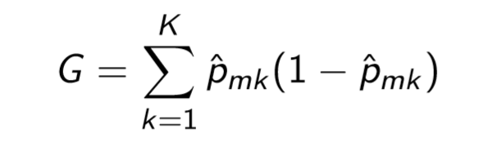
- Entropy
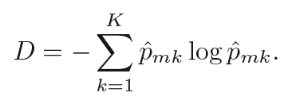
To calculate the overall information/entropy of a particular split of a dataset: 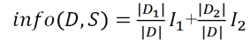

Classification Trees in R:
Package 1: rpart
- Classification Trees (distinction from regression trees):
rpart (Target ~ decision variable, data, method="class",
parms=list(split="information"),control= rpart.control(usesurrogate,maxsurrogate,minsplit))))

- To build a maximal tree, use cp=0, minbucket=1, and minsplit=2
- Complexity Table: printcp(model) OR model$cptable

Package 2: rattle (visualization)
- fancyRpartPlot (model)
- asRules (model)

